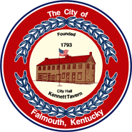 | CITY OF FALMOUTH  230 Main Street  Falmouth, Kentucky 41040  Phone (859) 654-6937 Fax (859) 654-3603  Interim Mayor Luke Price  lprice@cityoffalmouth.com  City Clerk/Treasurer Susan L. Bishop  sbishop@cityoffalmouth.com | Council Members  Joyce Carson  Sabrina Hazen  Amy Hurst  David Klaber  Bob Pettit  Brian Reid

CITY COUNCIL MEETING
6:00 PM

February 8, 2024

SPECIAL

AGENDA

- Call to Order
- Pledge of Allegiance
- Invocation
- Appointment of Fire Chief
- Adjournment

